IDCE-840CT
Battery Discharger & Capacity Tester
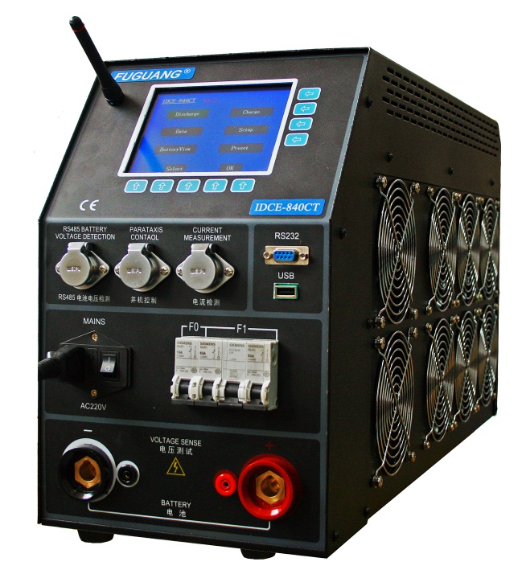
- Wide voltage range battery discharger: 10 V to 300 V
- 5.7 inch LCD touch screen for easy operation and showing various parameters real time
- Selectable discharge mode: constant current / power / resistance
- 4 adjustable stop points and multiple alarm designs to control the discharge process intelligently
- Support RS232 real time monitoring by PC or USB download data after discharge
- PC software for capacity evaluation and report generation
- Optional wireless modules for 1.2V/2V/6V/12V cells voltage real-time measuring

OVERVIEW
Although battery resistance testing methods are improving and very popular, battery discharge test still is the most accurate and reliable method for actual capacity evaluation of battery groups. Because only constant current discharge can perfectly simulate the working status under loading for batteries, power supply departments in many companies and utilities keep the periodic discharge testing in their maintenance management.

Because the DC power systems in various industrial utilities are using different voltage level battery groups (24V, 48V, 110V, 120V, 220V, 240V etc.), and most of the professional users hope to find an unattended and automatic instrument to simplify discharge process, the battery discharge tester with intelligent designs and super voltage variability for almost all battery types would be preferable.
FEATURES
Wide Range
IDCE-840CT can support 10-300V battery groups, the application of IDCE-840CT includes:
Battery Nominal Voltage | Max Discharge Current
240 V / 220 V | 60 A
120 V / 110 V | 120 A
96 V | 120 A
48 V | 120 A
24 V | 120 A
12 V | 60 A
Multiple Adjustable Stop Points
IDCE-840CT offers 4 adjustable points for test stop points to avoid excessive discharge:
Stop Point | Setting Range
Group Low Voltage | 0 - 250.0 V
Discharge Time | 0 - 99 Hour 99 Min
Discharge Capacity | 0 - 9999 AH
Cell Low Voltage | 0 - 15.00 V
IDCE-840CT also offers selectable quantity of cells which voltages below the stop point, this design could help you to locate more lag batteries in once constant discharging.
Selectable Discharge Modes
IDCE-840CT provides 3 discharge modes for different test requirements:
Discharge Mode | Range
Constant Current | 0 - 120 A
Constant Power | 0 - 14 Kw
Constant resistance | 0.16Ω - ∞
5.7 inch Touch LCD Display
Super big size touch LCD can display all real time data and graphs and support the click operations directly, humanized input method and menu designs simplified operating process.
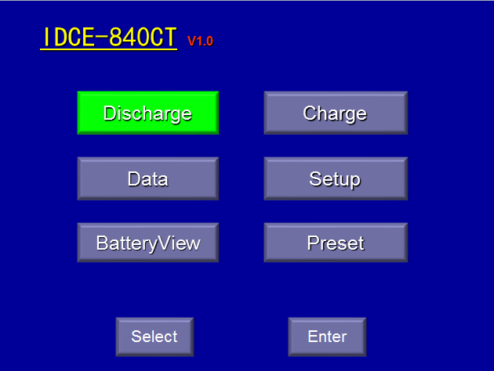
Presetting Function
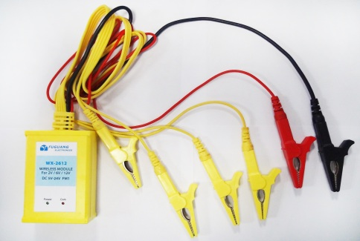
The presetting function for discharge parameters provides 8 locations for setting up all discharge parameters in advance, this design can skip the setting procedures for the same discharging, simplify the operation and speed up the test.
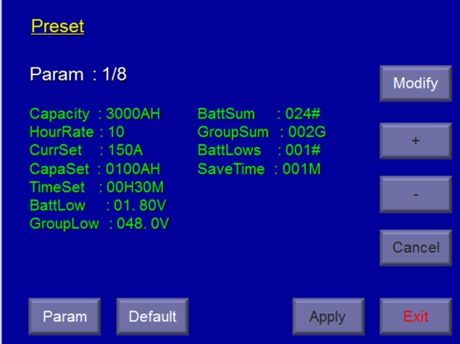
Internal Memory
- IDCE-840CT can save several independent discharge records automatically without Laptop monitoring, non-volatile internal memory guarantees the data security even in unexpected shutdown.
- The menu interface provides some management operations like reviewing, deleting, downloading to PC by USB disk or RS232.
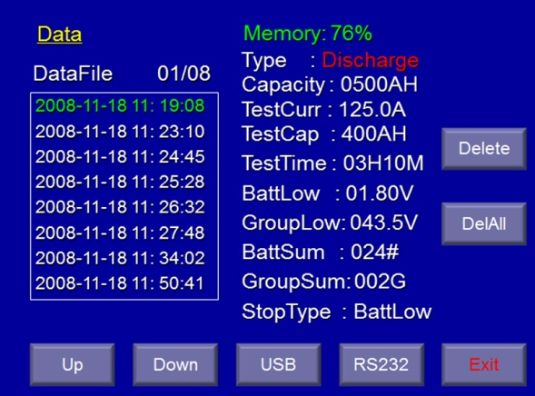
Optional wireless cells voltage monitoring
- Wireless modules for cells voltage measuring are available for 1.2V/2V/6V/12V batteries voltage monitoring during discharge test.
- Each wireless module can monitor 4 batteries simultaneously. Compared with the traditional cable voltage measuring method that each module only can monitor 1 battery, the new wiring operation is much easier.
- With proper number wireless modules, main tester can real time scan and display the voltage data of each battery during the discharging, and display the histogram of all batteries to follow the battery voltage tracks in whole discharging process.
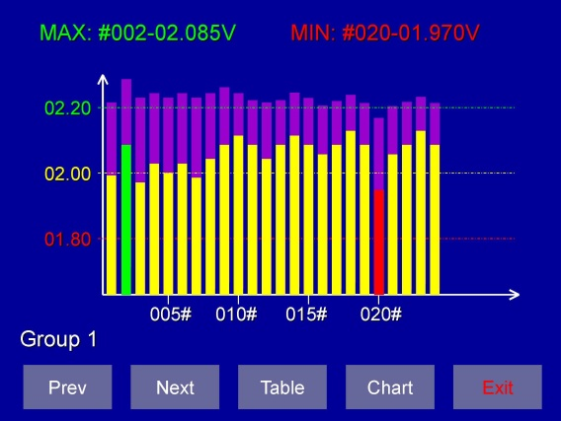
- Intelligent judge program: IDCE-840CT can identify the situations that the battery voltages reach the threshold value or the signal missing by manual mistake. Avoiding manual interruption in the discharging, this revolutionary program makes the test stable and smooth.
- IDCE-840CT also supports cable modules for special requirements.
Multiple Protections & Alarms
Malfunctions | LCD prompt | beep warning
Input over-voltage | √ | √
Reverse polarity | √ | √
Overload | √ | √
Overheat | √ | √
IDCE-840CT provides ample protective measures for various abnormal situations during discharge. Automatic termination, LCD prompt and beep warning would assist users to make proper treatments.
Extendable & Compatible
Connected with clamp current, IDCE-840CT cooperate other types in IDCE-CT series or any other load units, and clamp current can count external current in.
PC ANALYSIS SOFTWARE
- Support data downloading and analyzing through real time communication or USB memory devices
- The software interface includes: battery voltages curve and bar chart, battery resistances bar chart, group voltage curve, current curve, capacities histogram, data form and so on.
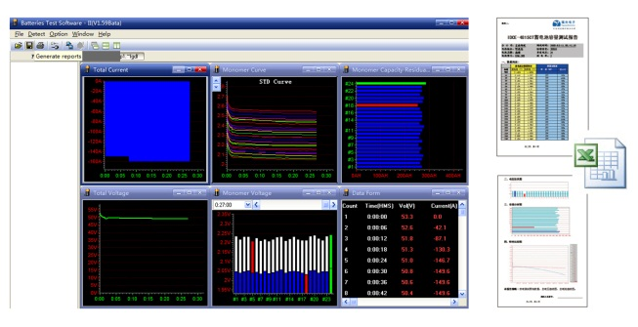
- Powerful capacity estimating function, the software can predict the capacity of each battery in the tested group.
- The software shows the data by various ways like bar charts, curve, and form. And users can magnify or minify any windows to read more details.
- Automatically create EXCEL data report, it’s so convenient to send or download the data.
TYPICAL APPLICATIONS
Single unit for 1 battery group
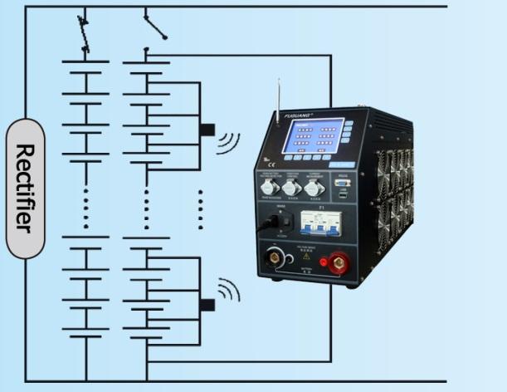
Single unit for 2 battery groups
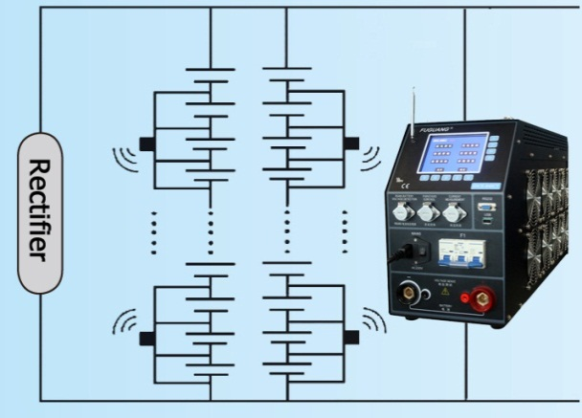
Parallel co-work for 1 battery group
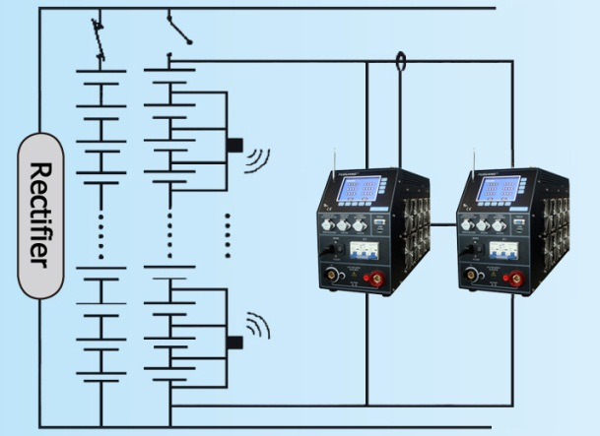
SPECIFICATIONS
Discharge Ranges
Voltage range | current range
8-15V | 0-60 A
18-30V | 0-120 A
40-60V | 0-120 A
70-140V | 0-120 A
140-280V | 0-60 A

Current measurement
Internal current range | 0-120 A
Accuracy & resolution | ≤±0.5%, 0.1 A
External current range | 0-600 A(optional current clamp)
Accuracy & resolution | ≤±1%, 0.1 A

Voltage measurement
Group voltage range | 10-300 V
Accuracy & resolution | ≤±0.5%, 0.1 V
Cell voltage range | 0-15V
Accuracy & resolution | ≤±0.5%, 0.01 V

Power Supply
Power supply voltage | 220 V AC (-20% to +30%)
Frequency | 50/60 Hz
Power consumption | 350W(max)

Communication & Storage
Communicate port | USB/RS232
Internal memory | 8Mbit Flash

CE Certificate
LVD standards | 2006/95/EC: EN 61010-1:200
EMC standards | 2004/108/EC Annex II:  EN 61000-6-1:2007  EN 61000-6-3:2007  EN 61000-3-2:2006+A2:2009  EN 61000-3-3:2008

Environment
Operation temperature | -5 to 50º C
Storage temperature | -40 to 70º C
Humidity | 5% - 95% RH
Altitude | below 4000 m
Working noise | <60 dB

Dimensions & Weight
Main tester | 230 x 370 x 670 mm
Carrying case | 370 x 600 x 800 mm
Weight | 24 kg (main tester only)  46 kg (included all accessories and carrying case)  0.3 kg (each optional wireless module)

Accessories
Carry case | 1 x 370 x 600 x 800 mm, 15kg
Power cable | 2 x 3 m cables 50 mm²
AC power cord | 1 x 3 wires x 1 mm²
Software | 1 x CD-ROM
RS232 wire | 1
User manual | 1
USB disk | 1 x 2GB
Current clamp | 1 x 200A or 600A (Optional)
Ordering Information
Type | Description
IDCE-840CT | Battery discharge & capacity tester
IDCE-AS | PC analysis software
IDCE-200CC | 200A current clamp
IDCE-600CC | 600A current clamp
WX-2612 | Wireless module for 2V/6V/12V
WX-12612 | Wireless module for 1.2V/2V
YX-12612 | cable module for 1.2V/2V/6V/12V

